Issue 1: Global character graph is still not fixed
Currently it looks like this:
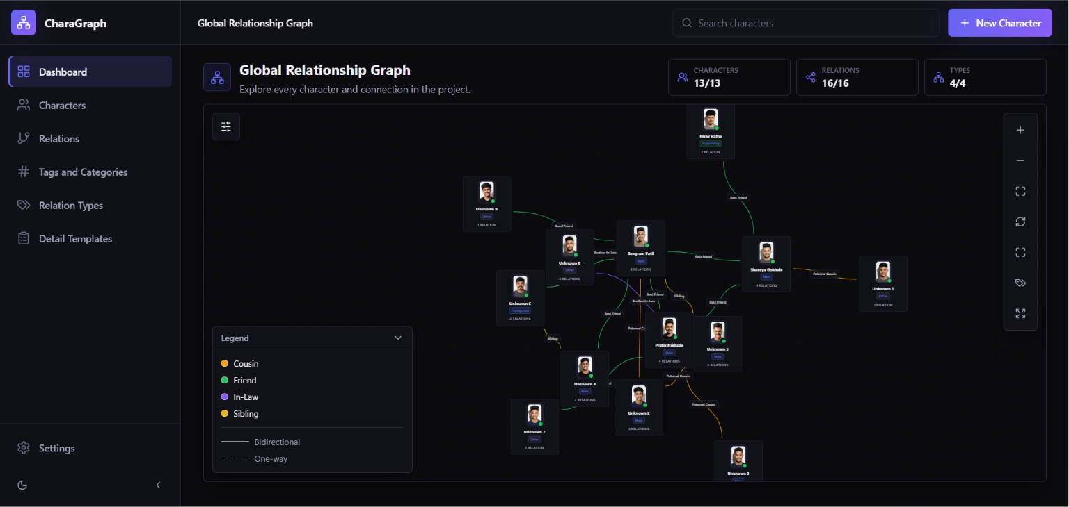
Which is really messed up structure. I want it like this:
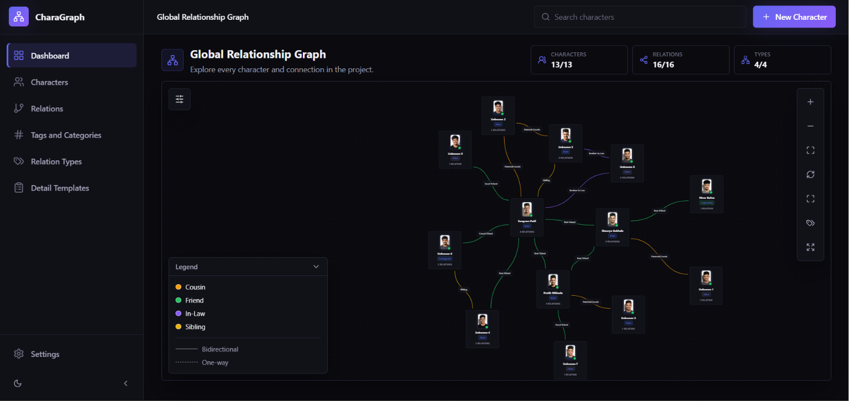Basically I want the structure like this where there is no overlapping unless it is extremely necessary:
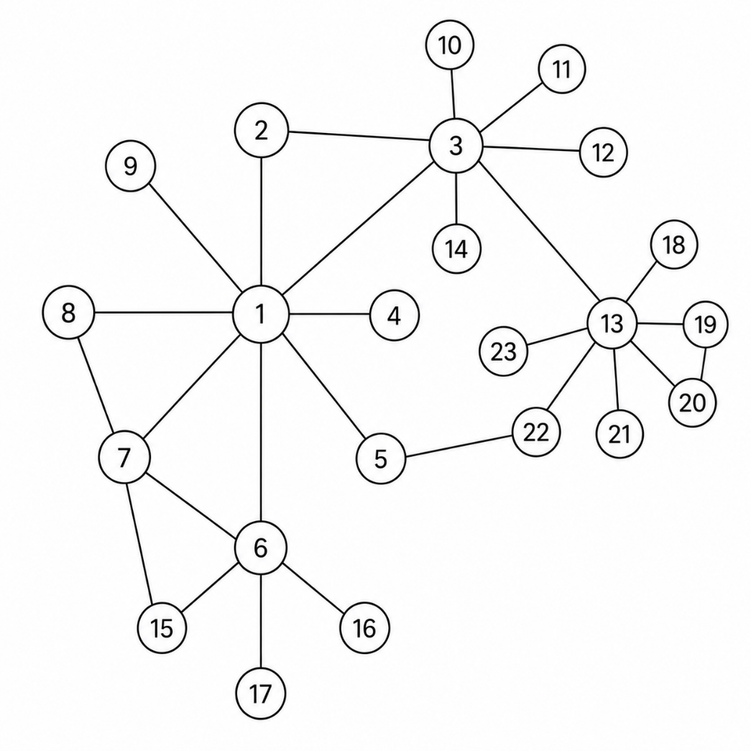
Location: Dashboard (global character graph)

